**3.1 Hardware Components:**

**3.1.1 Heart Rate Monitor**  
The Heart Rate Monitor is used to measure the electrical activity of the heart. It uses AD8232 as its core chip which is one of the popular integrated signal conditioning block for ECG and other bio-potential measurement applications.

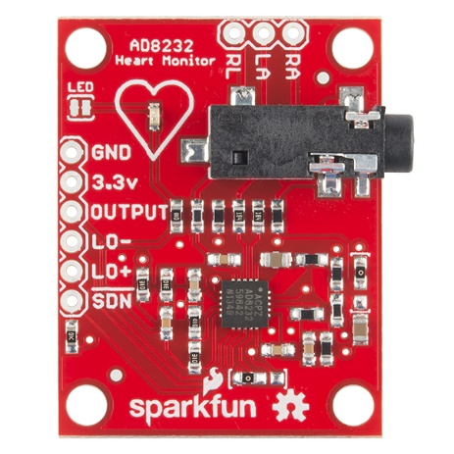 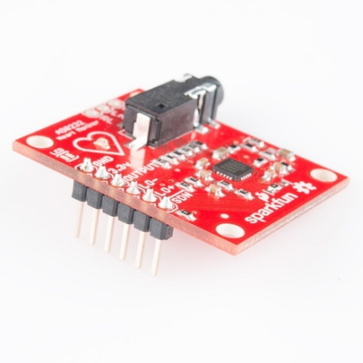

The AD8232 Heart Rate Monitor breaks out six essential connections from the IC SDN, LO+, LO-, OUTPUT, 3.3V, GND for operation. The Board also has RA(Right Arm),LA(Left Arm) and RL(Right Leg) pins for custom application. Additional features are listed below:

1. Analog Output
2. Leads-Off Detection
3. Shutdown pin
4. LED indicator
5. 3.5mm Jack for Biomedical Pad connection

**AD8232 :**One of the popular and widely used IC for extraction and filtering of biopotential signals in various bio-medical applications is the AD8232. The features that make AD8232 appropriate for these applications are:   
1. The AD8232 implements a two-high pass filter for eliminating motion artifacts which often affect the small bio potential signals.

2. Three pole low pass filter: The implementation of this filter allows the IC to remove additional noise.

3. Fast restore function: In many applications due to the low cut-off frequency used in the high pass filters, signals may require longer settling time. This long settling time could cause an unwanted delay in obtaining the signal. Hence this function reduces the duration of long settling tails of the high pass filters.

4. Specialized instrumentation Amplifier: The IC has contains a multi-purpose Instrumentation Amplifier which amplifies the ECG signal while rejecting the electrode half-cell potential on the same stage.

5. Right leg drive amplifier: The common mode output at the instrumentation amplifier is inverted by the right leg drive (RLD) amplifier. When the right leg drive output current is injected into the subject, it counteracts common-mode voltage variations, thereby improving the common-mode rejection of the system.

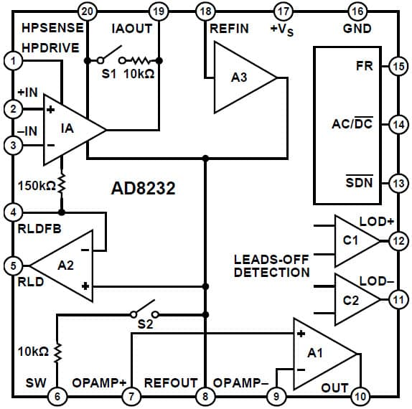

Caption

All the above feature allows AD8232 to extract, amplify, and filter small bio-potential signals in the presence of noisy conditions.

**3.1.2 Rapsberry Pi**The Raspberry Pi is a series of small single board computers developed by the Raspberry Pi Foundation. These boards are approximately credit-card sized and have a standard mainline form-factor.

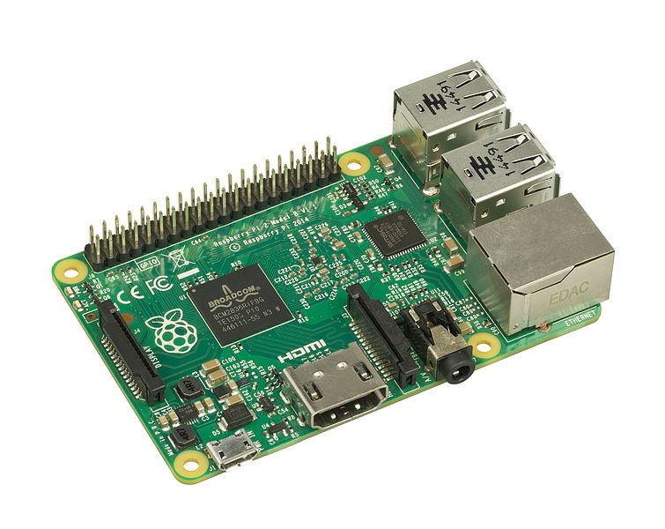

CAPTION

Several generations of Raspberry Pi have been released. The version used in this project is Raspberry Pi 2 Model B.  
All models of Raspberry Pi have a Broadcom system on chip (SoC) which includes an ARM compatible central processing unit (CPU) and on chip graphic processing unit (GPU).  
The specifications (specs) of Raspberry Pi 2 are:

1. Processor: Broadcom BCM2836 SoC with a 900 MHz 32-bit quad-core ARM Cortex-A7 processor with 256 KB shared L2 cache.
2. Random Access Memory(RAM): 1 GB of RAM
3. Peripherals: 17 General purpose Input Output(GPIO) plus specific function pins have been provided
4. Network: There is separate Ethernet port provided to support 10/100Mbps
5. There are 4 additional Universal Serial Bus(USB) provided for connecting peripherals like keyboard, mouse
6. Storage: There is a separate Secure Digital(SD) card slot provided
7. Power source : 5V via Micro USB or GPIO header
8. Audio output: A 3.5mm audio Jack is provided which can support analog output.
9. Video input: 15-pin MIPI camera Interface(CSI) connector

10) Video Output: High-Definition Multimedia Interface (HDMI) provided for video output

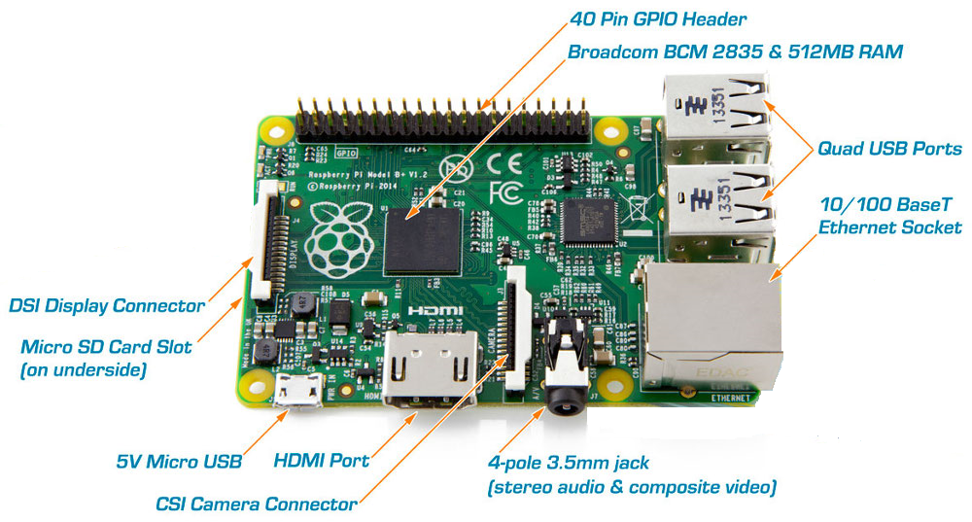

CAPTION

**3.1.3 Analog to Digital Converter (ADC)**

Analog to Digital convertor is a system that converts an analog signal into a digital signal. There are various ADC available in the market of which MCP3008 is used in this project. It is a 10-bit ADC with on board sample and hold circuitry.

Some of the features of MCP3008 are:

1. 10 bit resolution
2. 8 input channel
3. Serial Peripheral Interface (SPI) serial interface
4. High sampling rate   
   200 kilo samples per second (ksps) at a supply voltage of 5V and 75 kilo samples per second (ksps) at a supply voltage of 3.3V

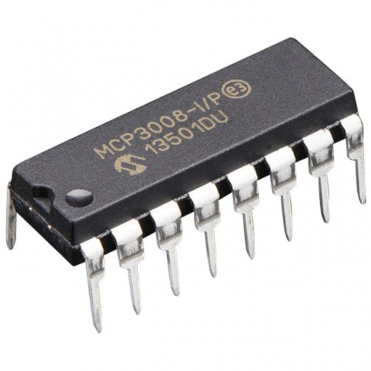 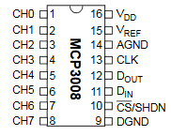

**3.1.4 Communication protocols**

Following are the two communication protocols used in this project:

1. Serial-Peripheral Interface (SPI) protocol:   
   SPI is a synchronous data bus used to send data between microcontrollers and small peripherals such as shift registers and sensors. Here synchronous data bus means that it uses separate clock and data lines.   
   The clock is an oscillating signal that tells the receiver exactly when to sample the bits on the data line. This can be the rising or falling edge of the clock signal.When the receiver detects that edge, it will immediately look at the data line to read the next bit.

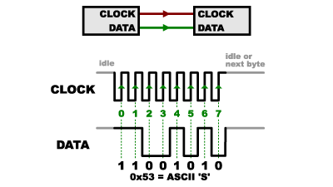

CAPTION

In SPI, only one side generates the clock signal.The side that generates the clock is called the “master”, and the other side is called the “slave”. There is always only one master which is the microcontroller,but there can be multiple slaves.

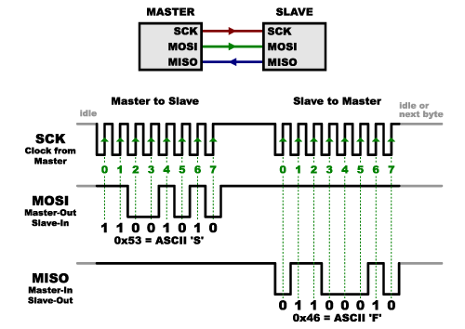

CAPTION

When data is sent from the master to a slave, it is sent on a data line “Master Out / Slave In”(MOSI). If the slave needs to send a response back to the master, the master will continue to generate a prearranged number of clock cycles, and the slave will then put the data onto a third data line called “Master In / Slave Out”(MISO).   
Advantages of SPI:

1. It is faster than asynchronous serial
2. The receive hardware can be a simple shift register
3. It supports multiple slaves

Disadvantages of SPI:

1. It requires more signal lines (wires) than other communications methods
2. The communications must be well-defined in advance
3. The master is in control of all communications
4. Secure Shell:   
   Secure Shell (SSH) is a widely used cryptographic network protocol for operating network services securely over an unsecured network. The best application of it is for remote login to computer systems by users.  
   SSH provides a secure channel over an unsecured network in a client-server architecture, connecting an SSH client application with an SSH server.

Some popular uses of SSH are:  
(a) For login to a shell on a remote host  
(b) For executing a single command on a remote host  
(c) For setting up automatic login to a remote server  
(d) Secure file transfer

**3.2 INTEGRATION:**

**3.2.1 Setting up Raspberry Pi  
*##ALL THE WORK ON RPI is done on WINDOWS(Have to mention this in some place)***

**(a) SD card setup**

Raspberry Pi 2.0 does not come with a pre-built operating system. Instead the operating system has to be flashed on the SD card which is then inserted into the Raspberry Pi. The operating system on SD card is installed by using the following steps:

1. SD card is inserted into the SD card reader.
2. Win32DiskImager utility is downloaded from the Sourceforge Project page as an installer file, and the software is installed by running it.
3. The Operating System (OS) of choice is downloaded from official raspberry site. For this project Raspbian Wheezy was used.
4. The image of the OS is then extracted from the downloaded file.
5. The Win32DiskImager utility software installed is then opened.
6. The extracted image is then selected and ‘Write’ button is pressed to write the OS to the SD card.
7. On successful completion of the process the SD card is ejected and inserted into the Raspberry Pi.
   1. The Raspberry Pi is ready for use with Raspbian Wheezy installed.
   2. ##The Raspberry Pi is then connected to the Internet using Ethernet cable.

**(b) Internet Protocol (IP) address of Raspberry Pi (Rpi)**

In order to work with the Raspberry Pi the IP address of Pi is needed. There are two ways to obtain this:

1. Working with Rpi using Television (TV) mode:  
   In this method the Rpi is connected to a TV screen using HDMI cable. The Rpi is connected to a router using Ethernet connection for Internet connection.
2. The IP address is then obtained by typing in “ipconfig” in the terminal window of the Rpi.
3. Working with Rpi in “headless” mode :  
   In this case a static IP address is assigned by the user. This is the approach used in this project as it is not always convenient to have a TV screen. The steps to set the static IP address is as follows:  
   (a) SD card is removed from Rpi and then inserted into the SD card reader.  
   (b) The SD card contents are then opened.  
   (c) A file named “cmdline.txt” is opened using Notepad++  
   (d) At the end of the file the following line is appended:  
   Syntax: ip=<client-ip>:<server-ip>:<gw-ip>:<netmask>:<hostname>:<device>:<autoconf>  
   Example:  
   ip=169.254.3.14::169.254.56.85:255.255.0.0:rpi:eth0:off  
   (e) The file is then saved and SD card is safely ejected from the system and inserted back into the Raspberry Pi.  
   The Rpi is then connected to a laptop using Ethernet

**(c) Communicating with the Rpi**SSH protocol is used for establishing the communication between the Rpi and the laptop. For this a free and open-source terminal emulator called PuTTY is used. PuTTY supports many variations on the secure remote terminal, and provides user control over the SSH encryption key and protocol version.

**3.2.2 Connecting Heart Rate Monitor to RPi using ADC MCP3008** The following is the circuit diagram required for the setup:

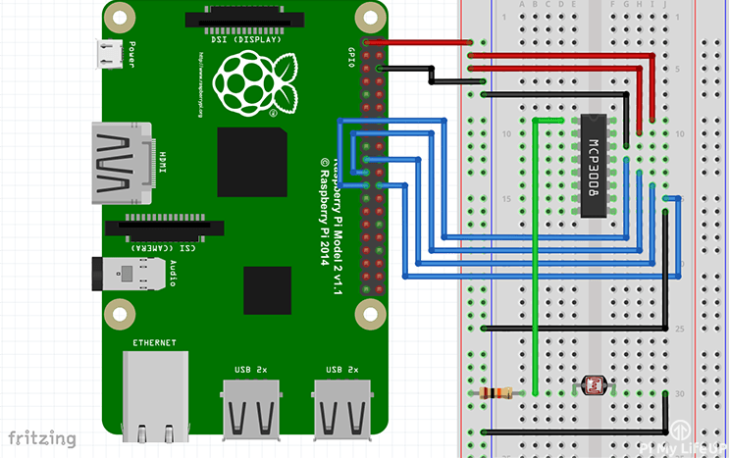First a 3v3 pin is connected to the positive rail on the breadboard and a ground pin to the ground rail on the breadboard. The following connections are made:

|  |  |
| --- | --- |
| **MCP3008** | **Rpi** |
| VDD (Pin 16) | 3.3V |
| VREF (Pin 15) | 3.3V |
| AGND (Pin 14) | GROUND |
| CLK (Pin 13) | GPIO11 (Pin 23/SCLK) |
| DOUT (Pin 12) | GPIO9 (Pin 21/MISO) |
| DIN (Pin 11) | GPIO10 (Pin 19/MOSI) |
| CS (Pin 10) | GPIO8 (Pin 24/CE0) |
| DGND (Pin 9) | GROUND |

**Signal Analysis**One of the most well know signal analysis tools used by analysts all around the world is the Fourier Analysis. Fourier Analysis breaks the signal down into sinusoids of different frequencies.

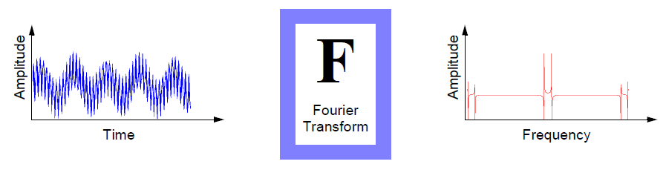

However Fourier Analysis has a serious drawback that when a signal is transformed from time domain to frequency domain, the time information is lost. This drawback is not important for stationary signals. But most real world signals contain numerous non-stationary or transitory characteristics: drift, trends, abrupt changes, and beginnings and ends of events. These characteristics are often the most important part of the signal, and Fourier analysis is not suited to detecting them.

Another analysis method that overcomes the drawback of Fourier Transform is the Short Fourier Transform (STFT). The STFT is a sort of compromise between the time and frequency-based views of a signal. A signal is mapped into two dimensional function of time and frequency.

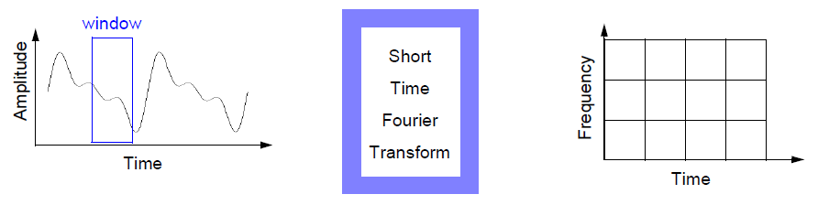

The drawbacks of STFT are:

(a) Limited precision depending on the size of window

(b) Once a particular size for the time window is selected, that window is the same for all frequencies

Hence there is a need for an analysis technique that represents a windowing technique with variable-sized regions. Wavelet analysis allows the use of long time intervals where more precise low frequency information is needed, and shorter regions where high frequency information is needed.

**Wavelet Analysis**

Wavelet analysis is the breaking up of a signal into shifted and scaled versions of the original wavelet. A wavelet is a waveform of effectively limited duration that has an average value of zero.

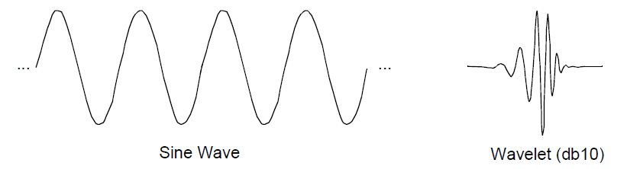

**Types of Wavelet Transforms:**

1. Continuous Wavelet Transform (CWT)   
   The continuous wavelet transform (CWT) is defined as the sum over all time of the signal multiplied by scaled, shifted versions of the wavelet function ψ:  
   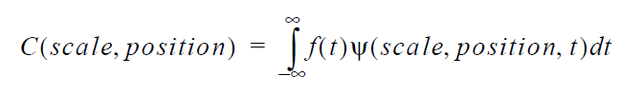

The output of the CWT are many wavelet coefficients C, which are a function of scale and position. These coefficients on multiplication by scaled and shifted wavelets yield the constituent wavelets of the original signal.

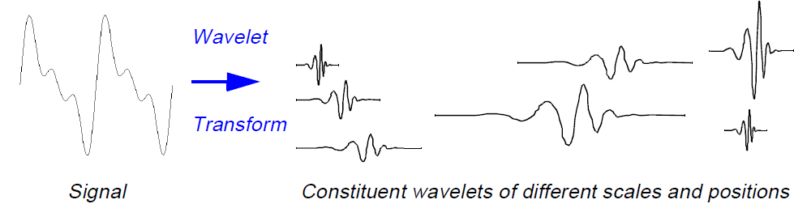

1. Discrete Wavelet Transform (DWT)  
   The Discrete Wavelet Transform(DWT) is a wavelet analysis technique in which the scale and position of the wavelets are varied in powers of two which is called dyadic scales and positions.

The wavelet transform method used in this project is DWT as the results can be more accurately determined by processing less number of data sets.

**Methodology used for performing DWT**

For most real world signal the low frequency content forms the most important part. For example consider human voice. If high frequency component is removed the voice sounds different but what is being said can still be understood. Now if low frequency components is removed then only gibberish is heard. Hence it can be said that the high frequency component imparts the flavor to the signal whereas the low frequency component forms the identity of the signal.

It is for this reason that discrete wavelet transform is divided into approximations and details. The approximations (A) are the high-scale, low-frequency components of the signal whereas the details (D) are the low-scale, high-frequency components of the signal.

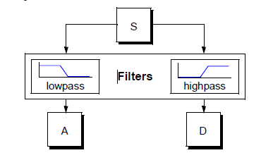

The original signal, S, passes through two complementary filters and emerges as two signals.

**Wavelet Decomposition Tree:**The decomposition process is iterated, with successive approximations being decomposed in turn. In this way the original signal is broken down into many lower-resolution components. This is called the wavelet decomposition tree.

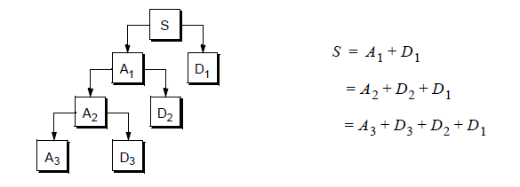

The detail coefficients (D) consist mainly of the high-frequency noise, while the approximation coefficients (A) contains much less noise than does the original signal. Hence in this way the decomposition coefficients of a signal are obtained.  
**Wavelet Families:**

There are various Wavelet Families from which the mother wavelet for analysis is chosen. Some of them are

1. Haar  
   The simplest of Wavelets is the Haar wavelet which resembles a step function.

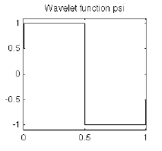

1. Daubechies  
   Often written as dbN, where N is the order, and db the “surname” of the wavelet, was invented by pioneer of Wavelet research, Ingrid Daubechies  
     
   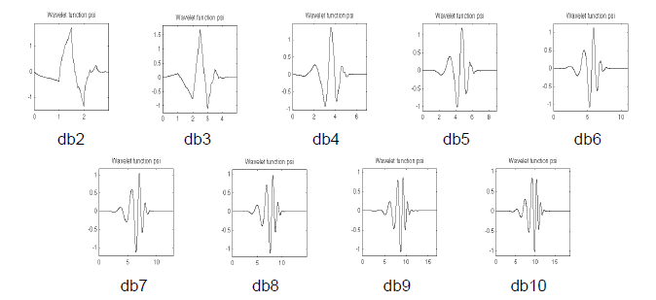
2. Biorthogonal  
   This family of wavelets exhibits the property of linear phase, which is needed for signal and image reconstruction.  
   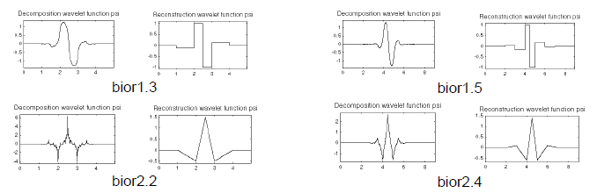
3. Morlet  
   This wavelet has no scaling function, but is explicit.  
   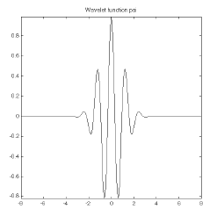
4. Mexican Hat  
   This wavelet has no scaling function and is derived from a function that is proportional to the second derivative function of the Gaussian probability density function.  
   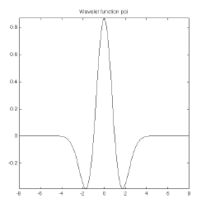

**Wavelet Transform on ECG signals:**ECG signals plays and important role in primary diagnosis and analysis of heart diseases. When an ECG is recorded many kinds on unwanted noise is also recorded with it. These noises cause an alternate shift in baseline of the ECG signal. A process of removing the baseline drift of a signal is called as de-trending.  
Wavelet transform is used in this project to de-trend the ECG signal that is obtained from the sensor.  
**Wavelet Selection:**The Daubechies wavelet of the DWT wavelet family is selected because the shape of the ECG signal and that of db5 is same. Also Daubechies wavelet families are similar in shape to QRS complex and their energy spectrums are concentrated around lower frequencies.  
**Methodology:**  
The signal is loaded into MATLAB’s Wavelet Analysis and Design Toolbox and the following results were obtained.  
 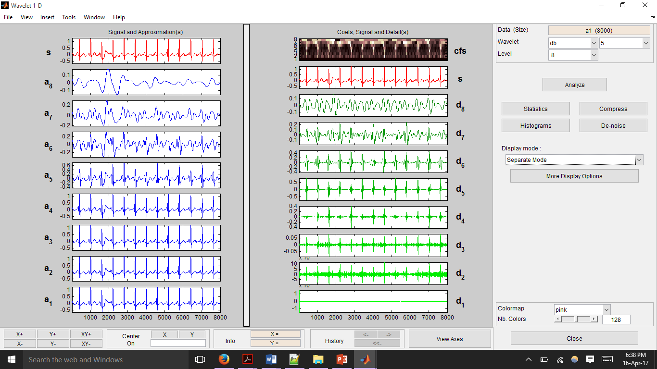

Fig1

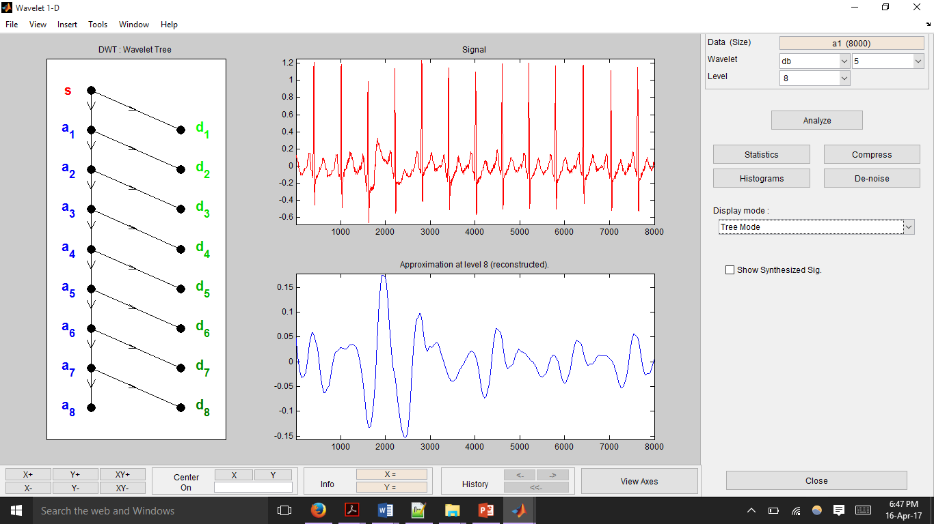

Fig 2

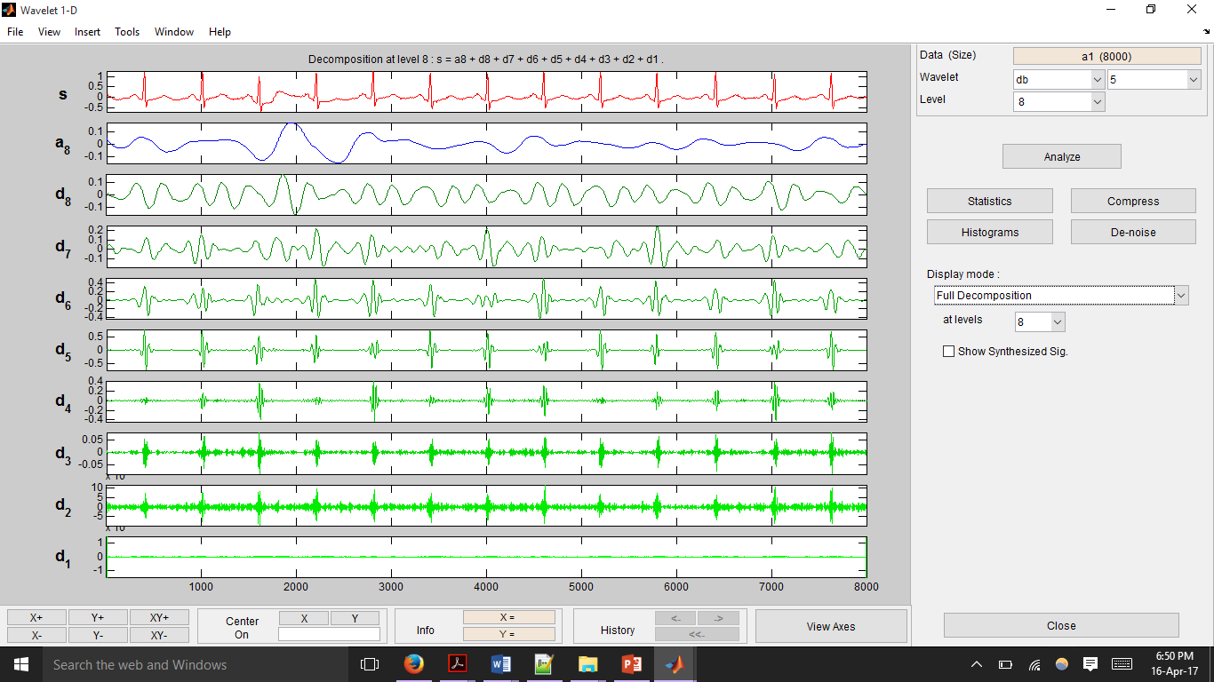

Fig 3

Fig1 shows the decomposition of the signal in separate mode. The right hand side depicts the high frequency decomposition components of the signal whereas the left hand side depicts the low frequency decomposition components of the original signal.

Fig2 shows the decomposition in tree mode. The wavelet tree is shown on the left. The original signal and the last low frequency approximation of the signal is shown on the right.

Fig3 shows the full decomposition of the signal according to the wavelet tree.  
  
**Methodology:**

From the decomposition of ECG signal it is seen that the low frequency component causes the baseline wandering. Hence these components have to be removed from the original signal to get a clean signal free from baseline wandering.  
From the above figures we can see that the low frequency component of the decomposed signal is a8.Therefore this component is subtracted from the original signal to get a de-trended signal.  
De-trended Signal = Original Signal – (A8)

Thus in this way Wavelet Transform is used to remove the baseline wandering present in the ECG signal.

**Output obtained:**

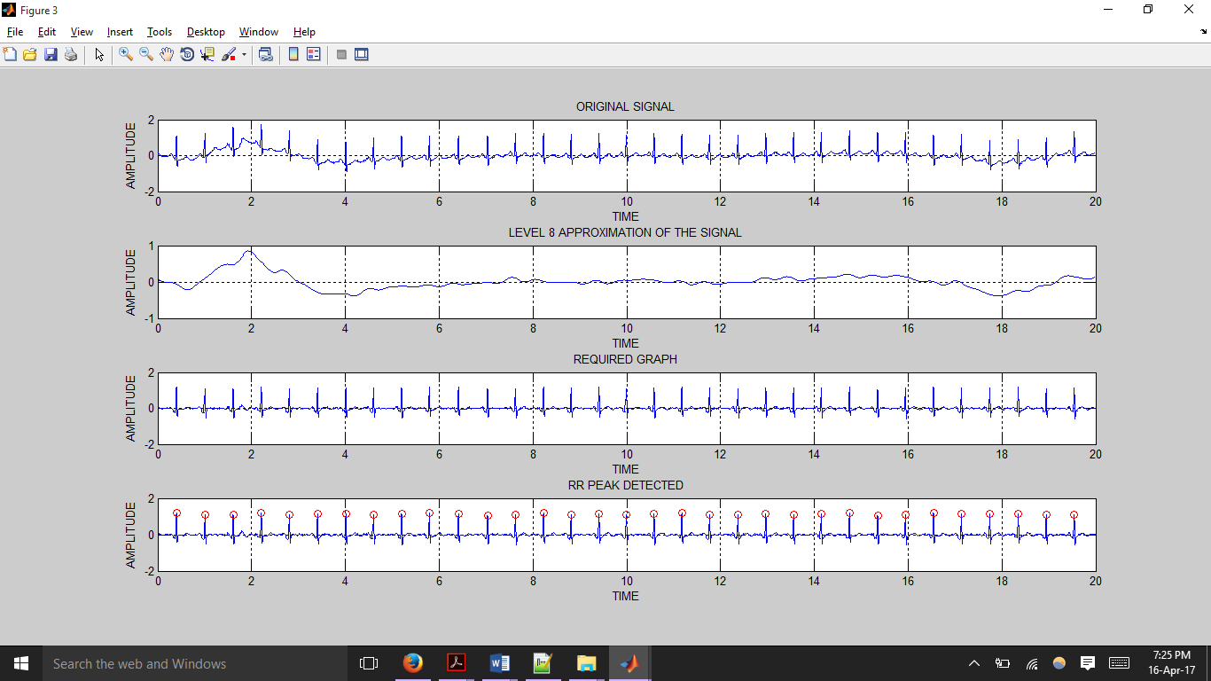

fig 4



fig5



fig 6



fig 7

fig4 shows the original ECG signal recorded from the sensor

fig5 shows the level8 approximation obtained after Wavelet analysis on the ECG signal

fig6 shows the de-trended signal

fig7 shows the RR-peaks detected after the detrending of the signal